* New features added.
  + Lambda expressions
  + Functional interfaces
  + Default method in interfaces
  + Static method in interfaces
  + Function interface
  + Predicate interface
  + Consumer interface
  + Method and constructor reference using :: operator like c++
  + Stream APIs for collections bulk operations
  + Time and date api, joda.org
* Why new features in java8?
  + Simplify the programming, now more code in less lines
  + Get benefits of functional programming but still maintaining object oriented concepts
  + Take the benefits of advance multi core processors – parallel processing benefits
* Lambda
  + Unfortunately Java has very lately started using lambda feature,
  + While other programming language has already started – LISP, C, C++, Objective C, C#.net, NodeJS, Ruby, Python
  + Advantages:
    - To enable functional programming
    - To write code easily readable, maintainable and concise
    - To enable parallel processing
    - To use APIs easily and effectively
* Lambda Expression/method
  + It is an anonymous method
    - No name
    - No modifier
    - No return type

|  |  |
| --- | --- |
| ~~public~~ ~~void~~ ~~add~~ ( int a, int b )  {  System.out.println( a + b )  } | ( int a, int b ) =>  {  System.out.println( a + b )  } |

* Type inference
  + Sometimes compiler can guess automatically the type of variable, that is why sometimes we don’t need to specify type of variable in lambda function/expression.

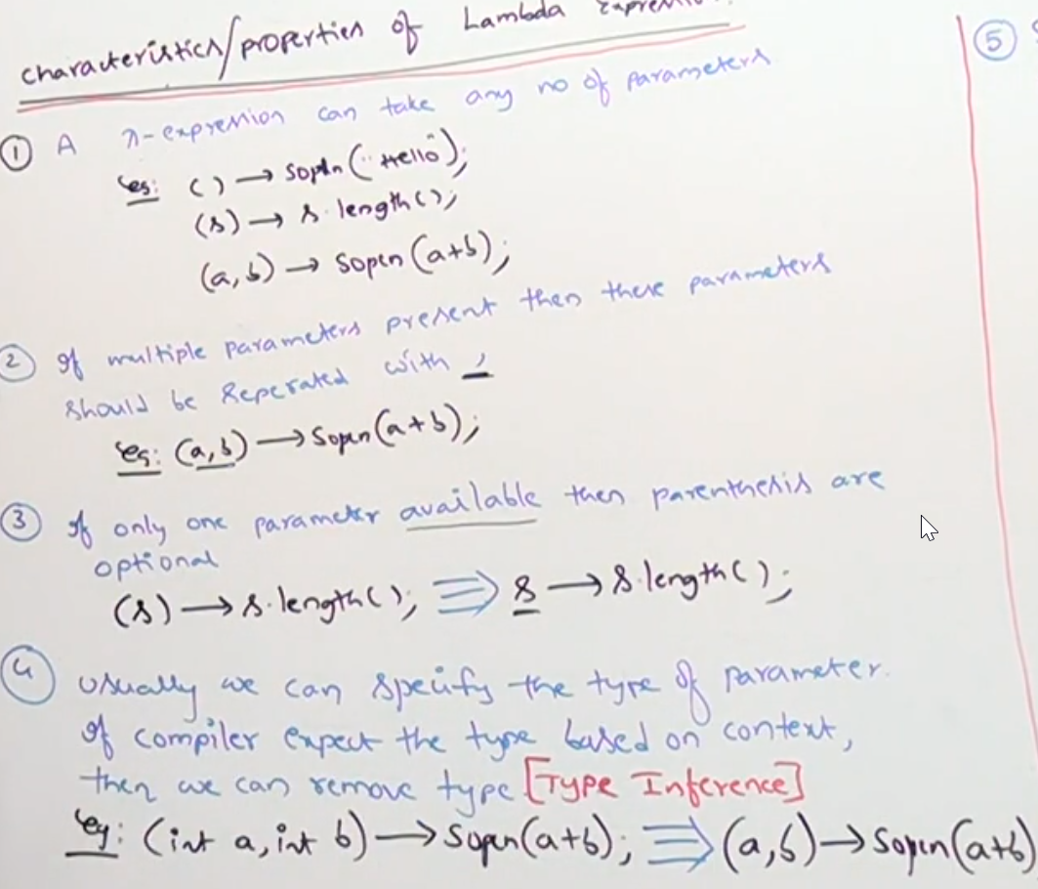 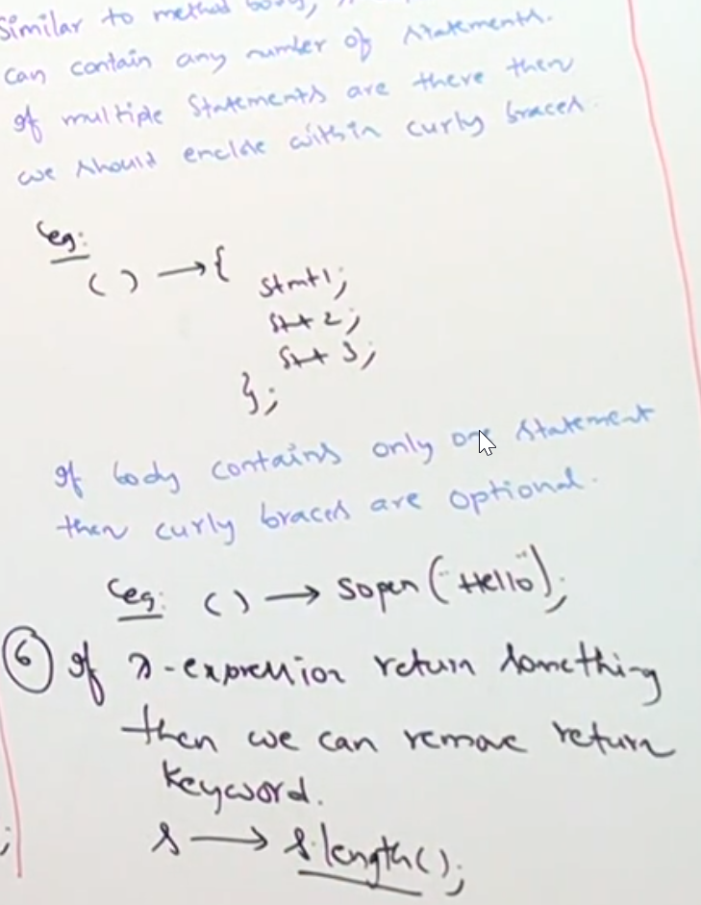

* Functional interface
  + Once we define our Lambda expression, if we need to call them we need functional interface.
  + Only one abstract method, but you can have N number of default method and N number of static method. Restriction is only for Abstract Method only. Only 1.

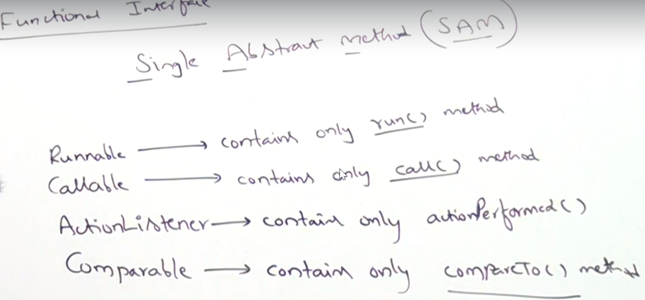

* @FunctionalInterface
  + To mark the interface as functional. If it will not follow the principle of functional interface and you used this annotation then it will give compiler error.

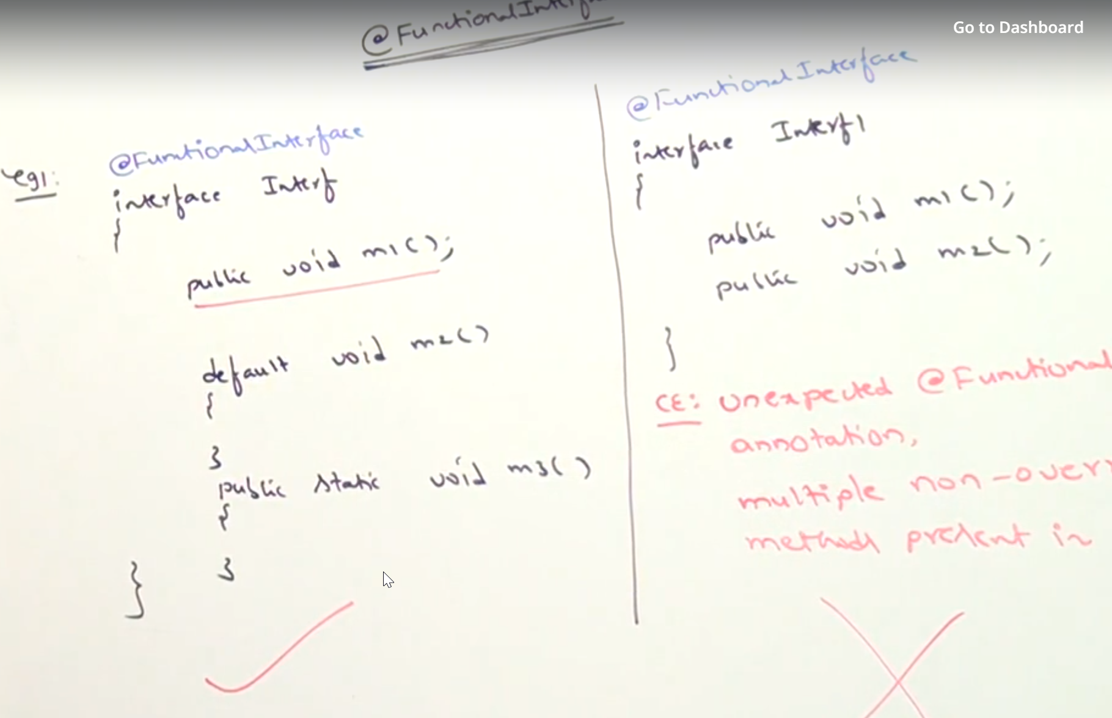

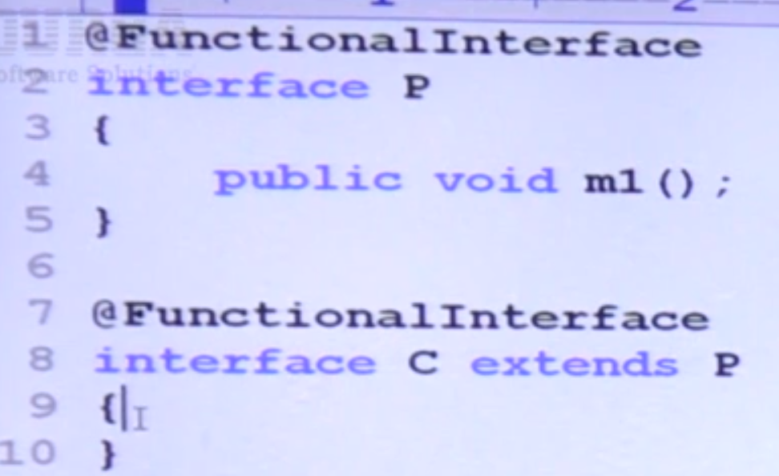 **VALID**

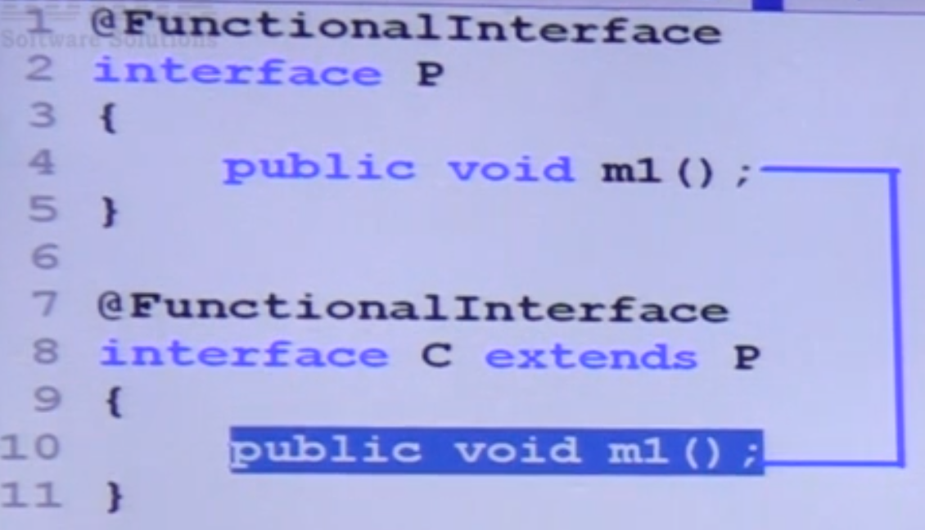 **VALID**

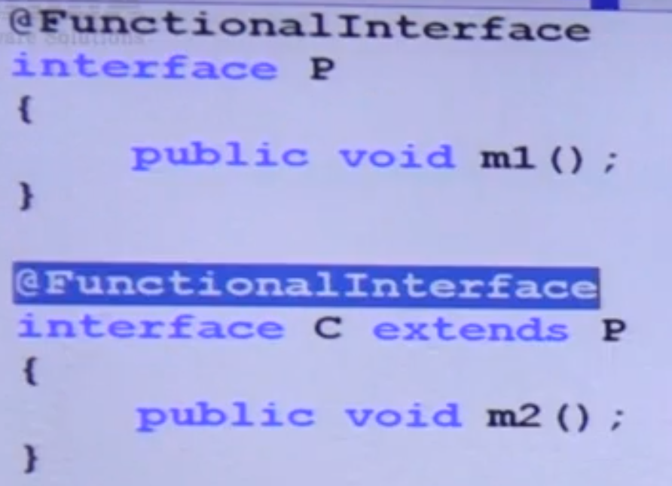

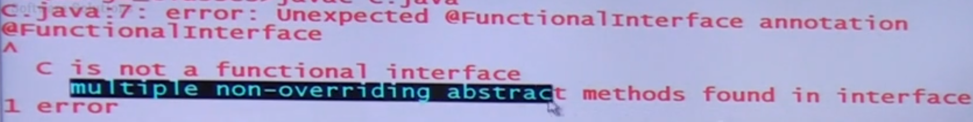

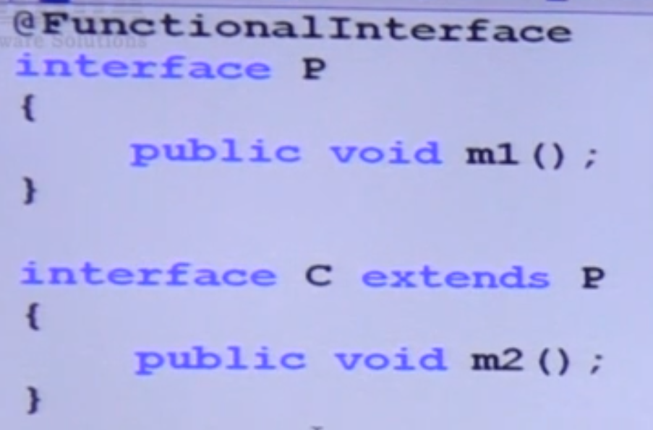 VALID – Child is like normal interface.

* **How to call or use lambda function/expression.**

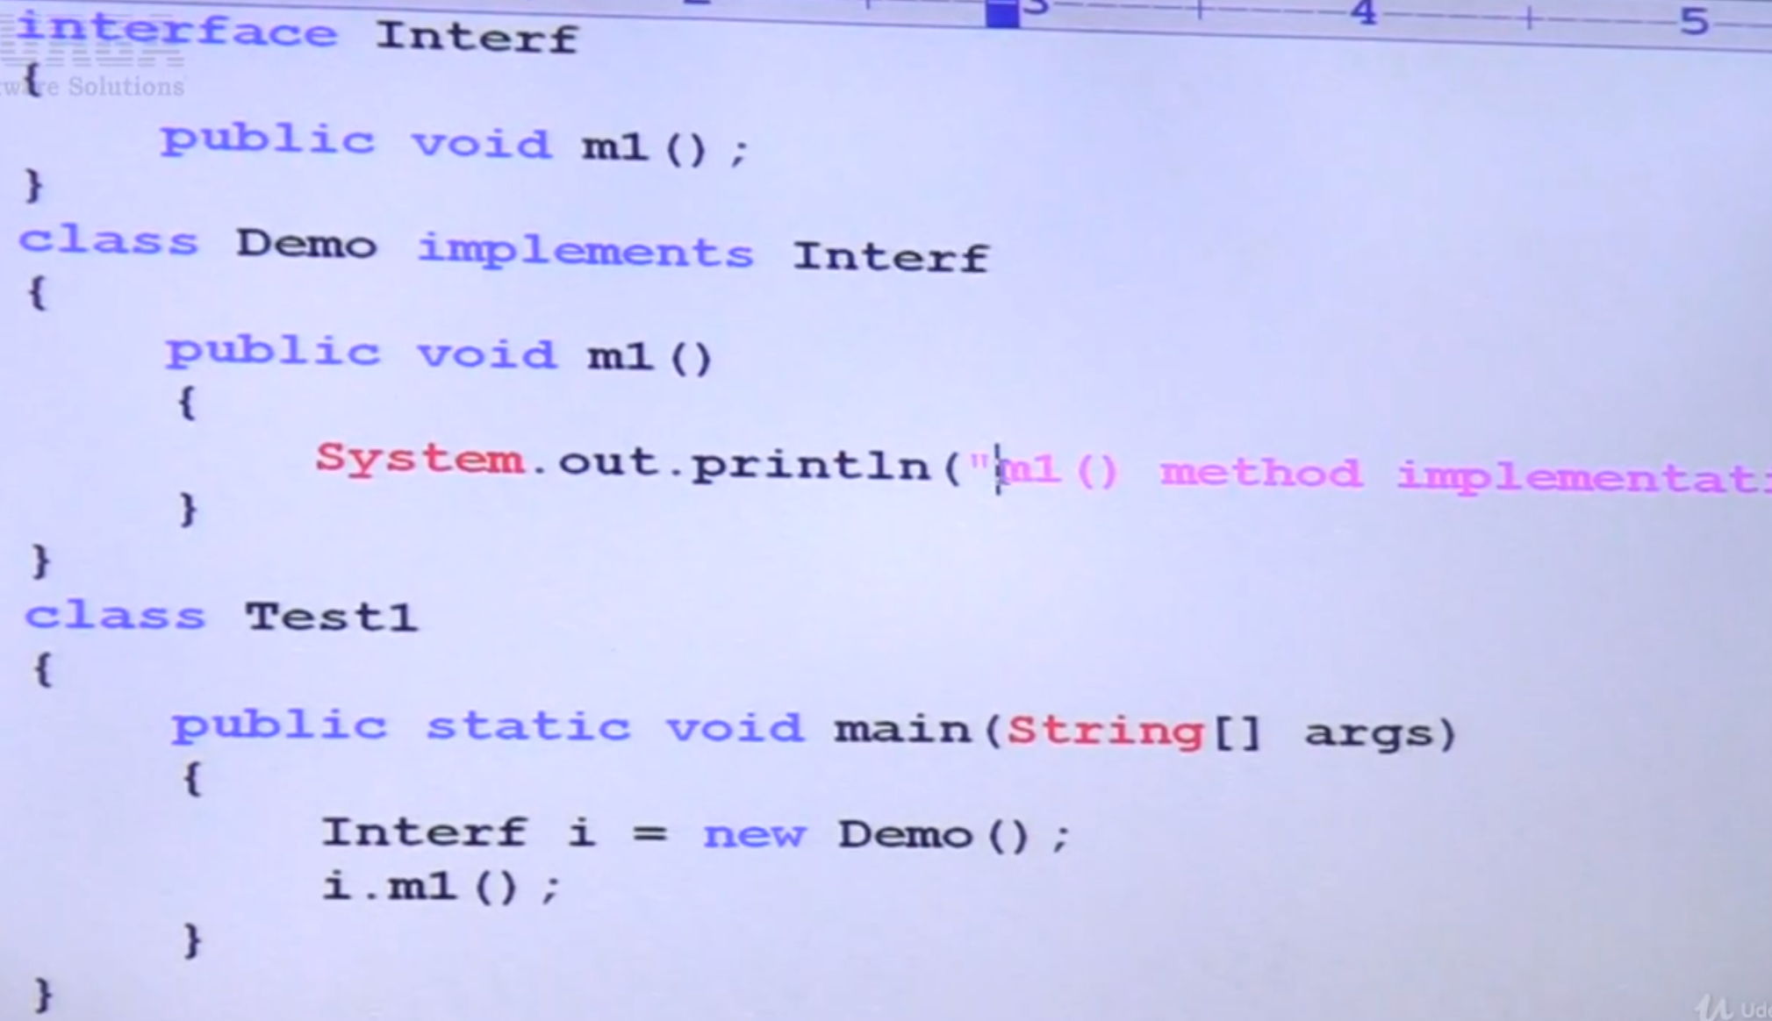 Java 7 code

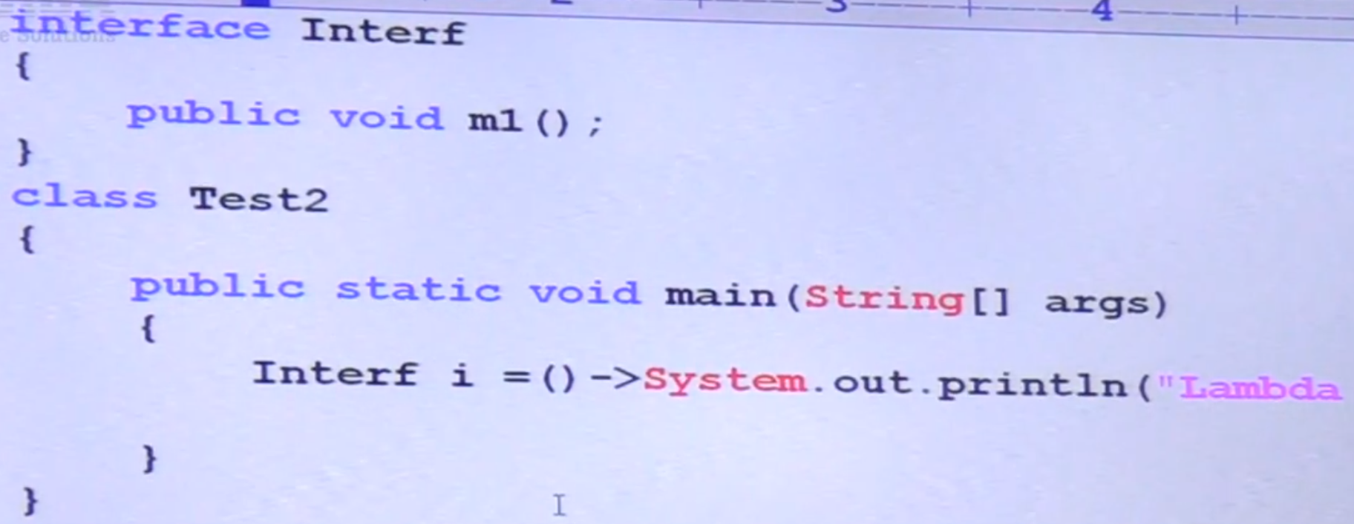

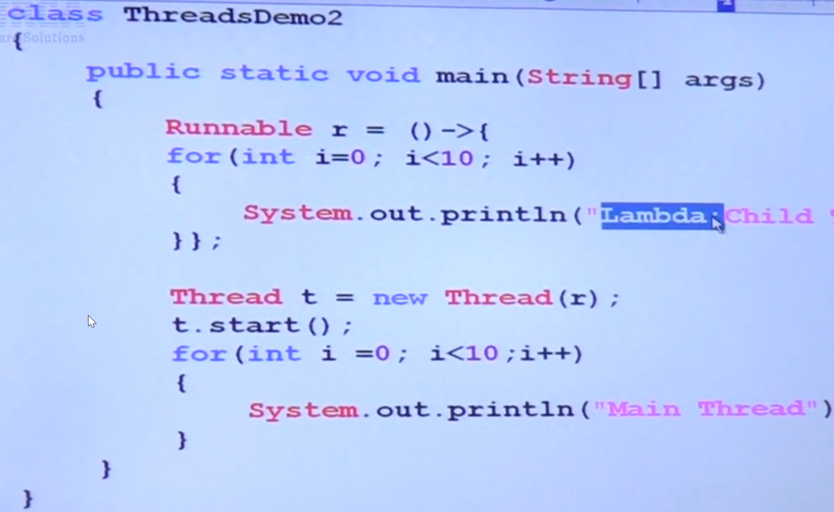

* If you want to use interface with lambda expression, interface must be a functional interface, that means compulsory only one method. If it has 2 methods compiler will be confused to use which method as an implementation….

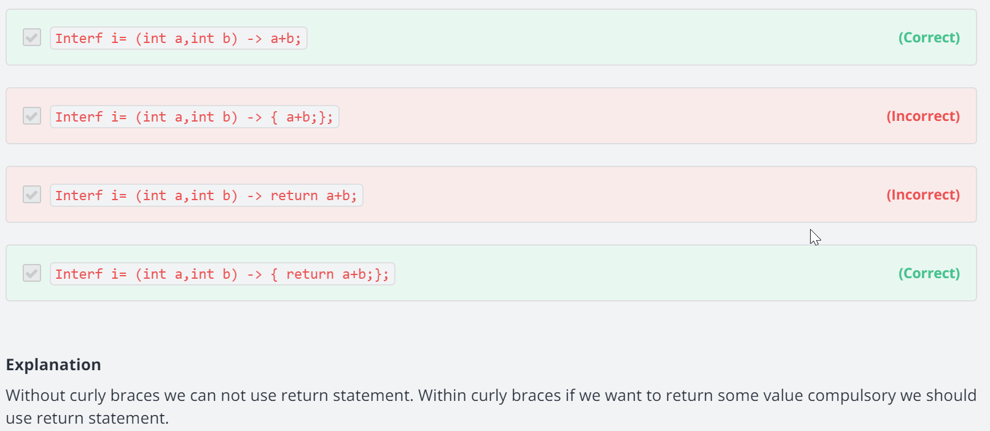

* IMP Points:
  + Without curly brackets we cannot use return statement.
  + If we use curly brackets and if we need to return value we must have to use return statement.
  + Within curly brackets we should have (; )semi colon.
* Anonymous Class VS Lambda expression
  + Less code – no need to declare definition of method, directly code method implementation.
  + Complexity of the code will be reduced,
  + Anonymous inner class can extend concrete class, abstract class, also can implement interface with single method (functional interface) and multiple methods as well.
  + So anonymous class and lambda expression both are not same, but they can be replaced where functional interface used.
  + Anonymous class have all class features like declaring instance variable and will have also access to same object using this keyword like Lambda expression there is no class or any object generated internally so variables you declare inside are local variables but not an instance and also this keyword always refers to parent class object. See programs below.

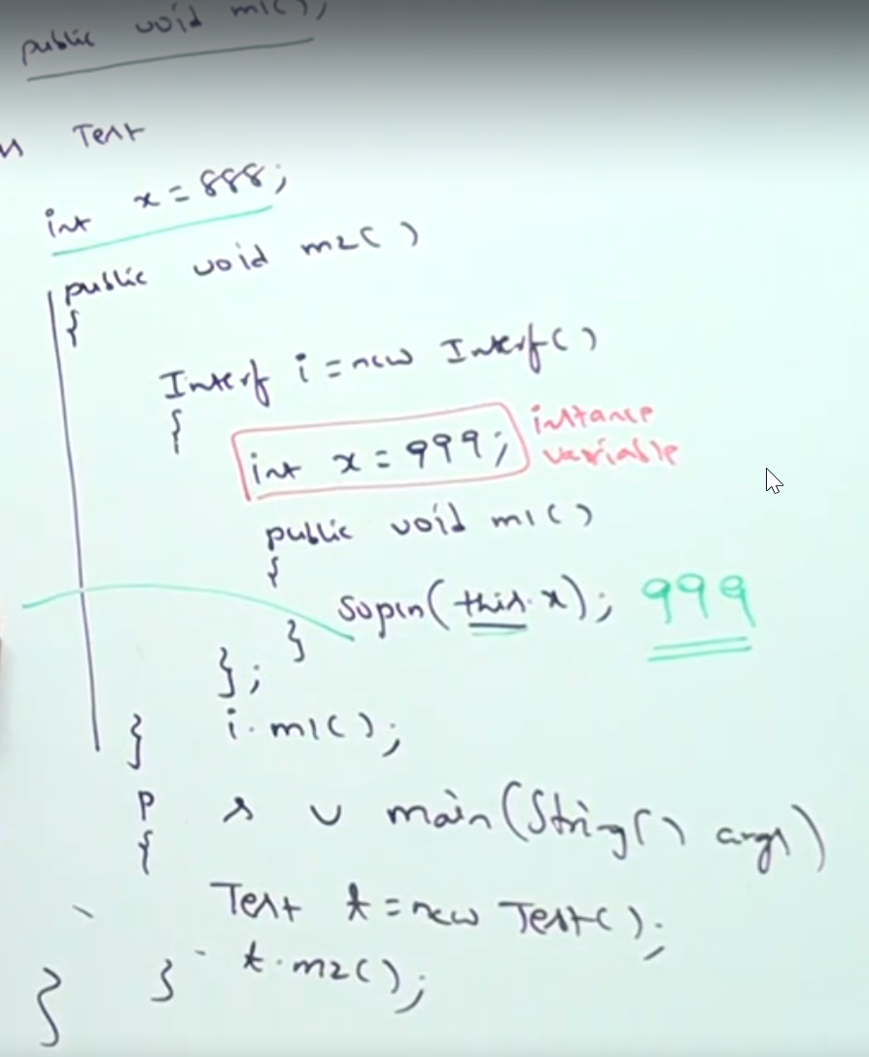 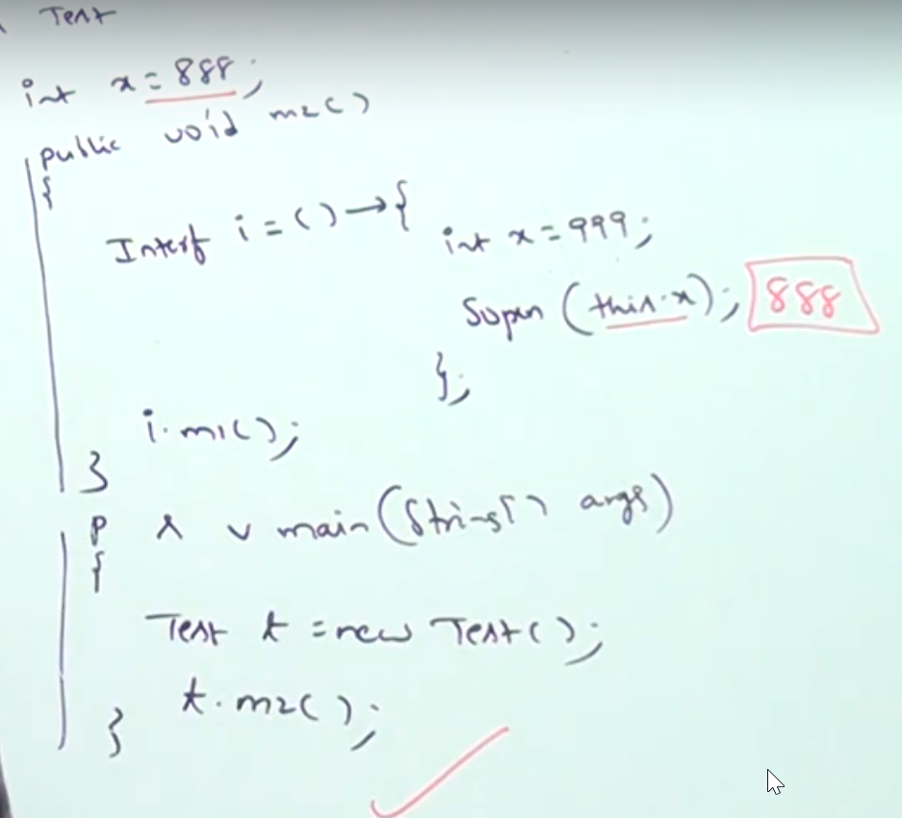

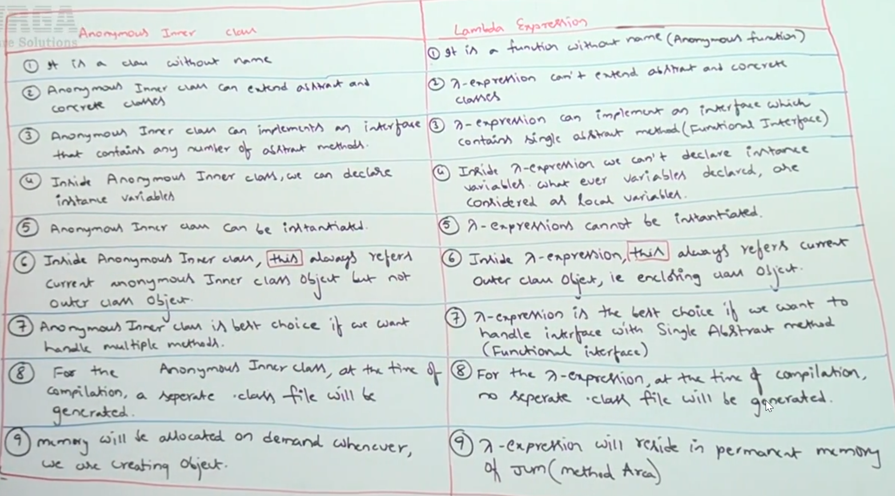

|  |  |
| --- | --- |
| **Anonymous Inner Class** | **Lambda Expression** |
| It is a class without name | It is a function without name |
| Can extend abstract class and concrete class | Cannot extend abstract or concerete class |
| Can implement interface having any number of abstract methods | Can implement interface with only one abstract method like functional interface |
| Can declare instance variables | Can declare only local variables |
| Can be instantiated | Cannot be instantiated |
| This keyword always refers the current inner class object but not an outer class | Always refers the current outer class. |
| Best choice when you want to handle multiple methods. | Best choice with functional interface |
| During compilation separate .class file will be generated | No separate .class file will be generate, |
| Memory will be allocated on demand when we create the object | Lambda expression will reside in permanent memory area of JVM only, i.e method local area. |

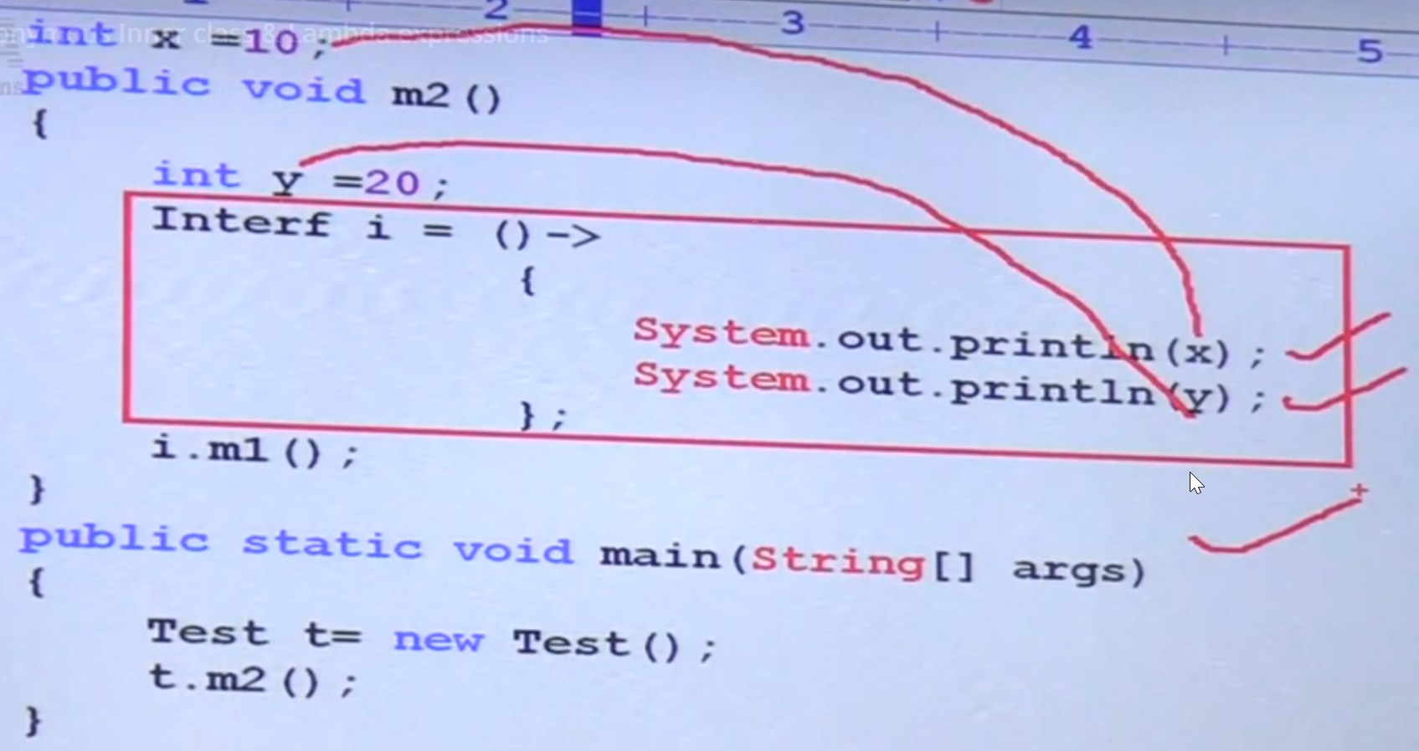

* Local variables referenced from the lambda expression are final, so you cannot change the value. Whole lambda expression code will be freeze.

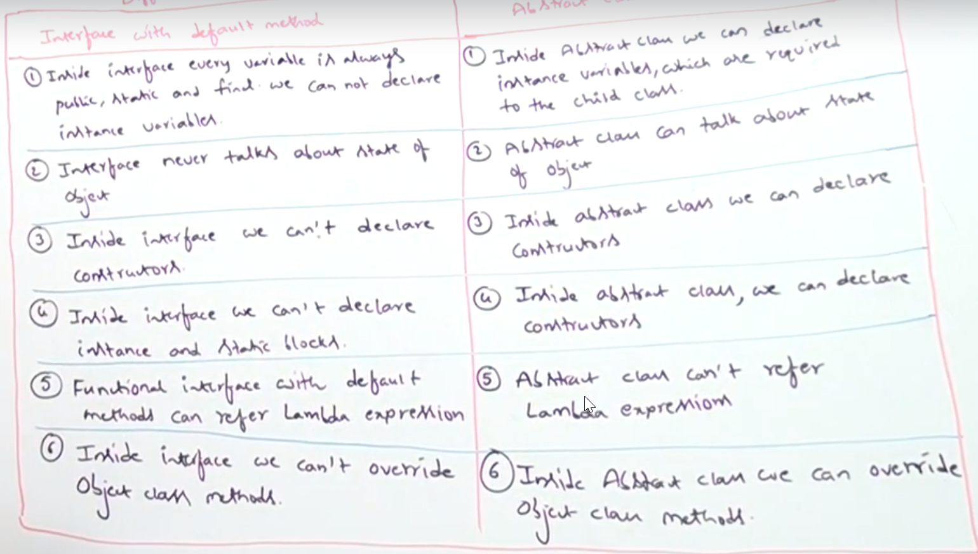

* Predicate
  + Boolean value function

@FunctionalInterface

**public** **interface** Predicate<T> {

**boolean** test(T t);

**default** Predicate<T> and(Predicate<? **super** T> other)

**default** Predicate<T> negate()

**default** Predicate<T> or(Predicate<? **super** T> other)

**static** <T> Predicate<T> isEqual(Object targetRef) {

**}**

* Functional
  + To perform certain operation and will return value based on type you define.

@FunctionalInterface

**public** **interface** Function<T, R> {

**default** <V> Function<V, R> compose(Function<? **super** V, ? **extends** T> before) {

Objects.*requireNonNull*(before);

**return** (V v) -> apply(before.apply(v));

}

**default** <V> Function<T, V> andThen(Function<? **super** R, ? **extends** V> after) {

Objects.*requireNonNull*(after);

**return** (T t) -> after.apply(apply(t));

}

**static** <T> Function<T, T> identity() {

**return** t -> t;

}

|  |  |
| --- | --- |
| Predicate | Function |
| To implement conditional check | To perform certain operation and return value based on the return type you provide |
| Takes one parameter which is input parameter | Can takes 2 parameters, 1 is input type and other is return type |
| Method name is test() | Method name is apply( |
| Return only Boolean | Returns return type you provide in second argument |

* Method reference
  + To refer the existing method implementation as a reference of Lambda expression functional interface implementation.
  + Code reusability is big advantage
  + It is an alternative syntax of lambda expression
  + Arguments must be different, other things no worries

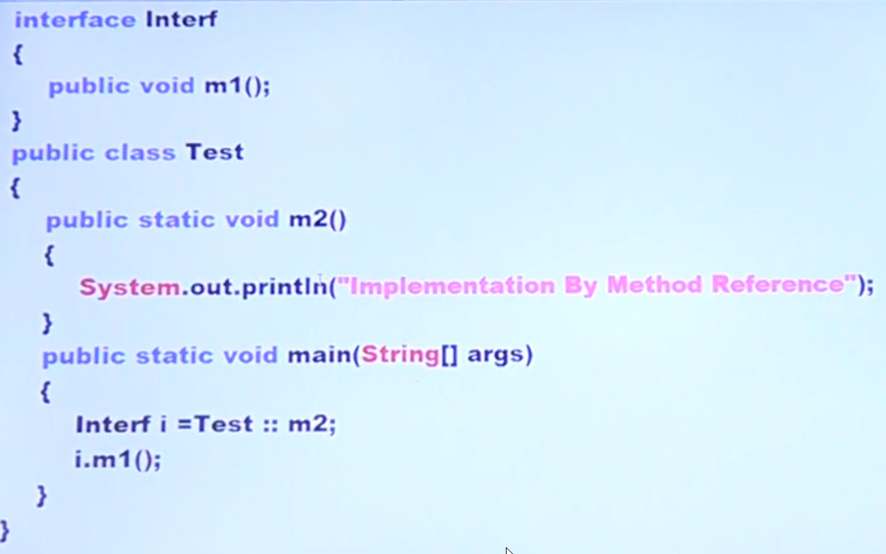

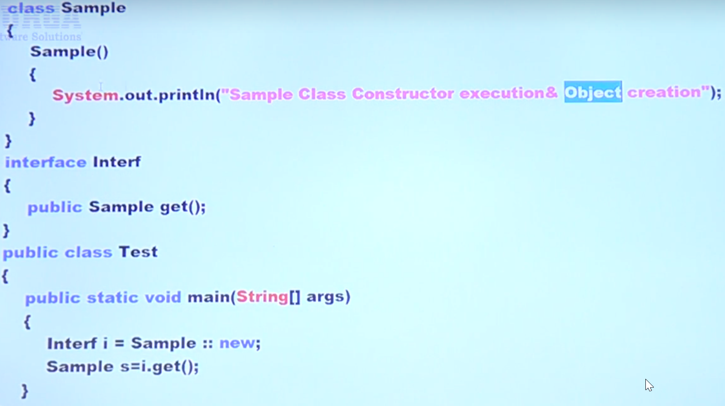

* Streams
  + Used to perform bulk operations in collections
  + > count, filter, map, collect, count, min, max, sort

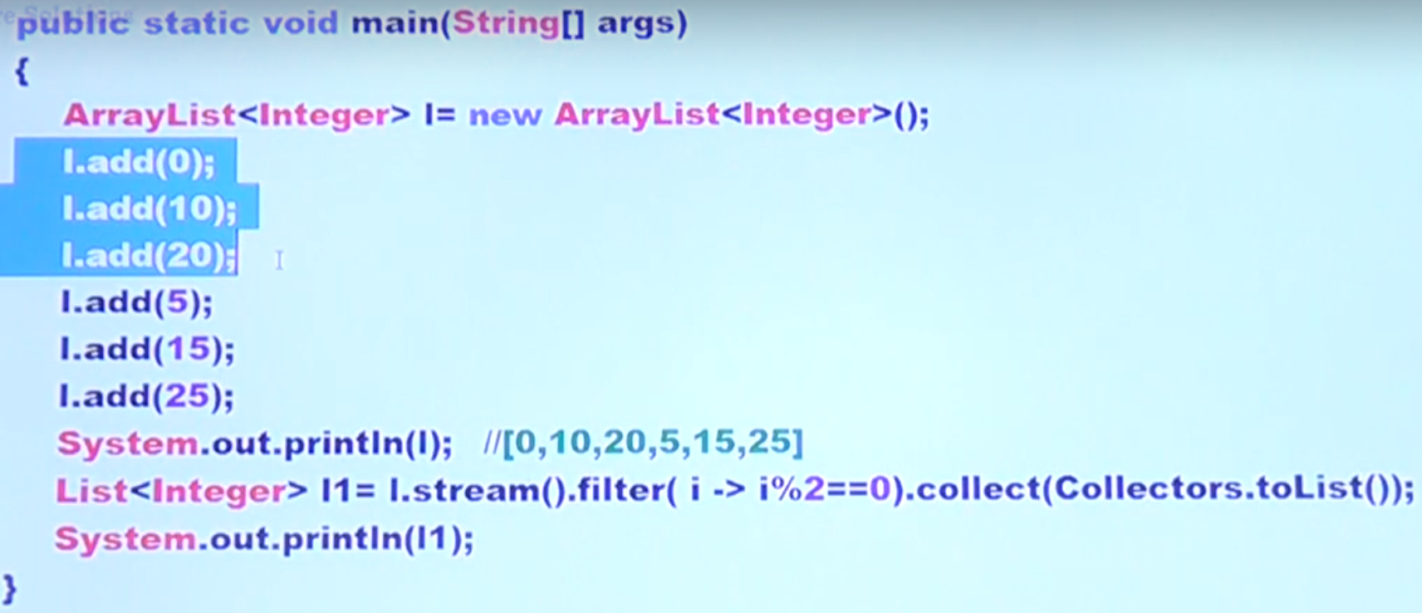

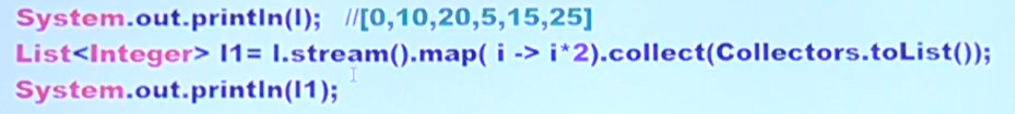

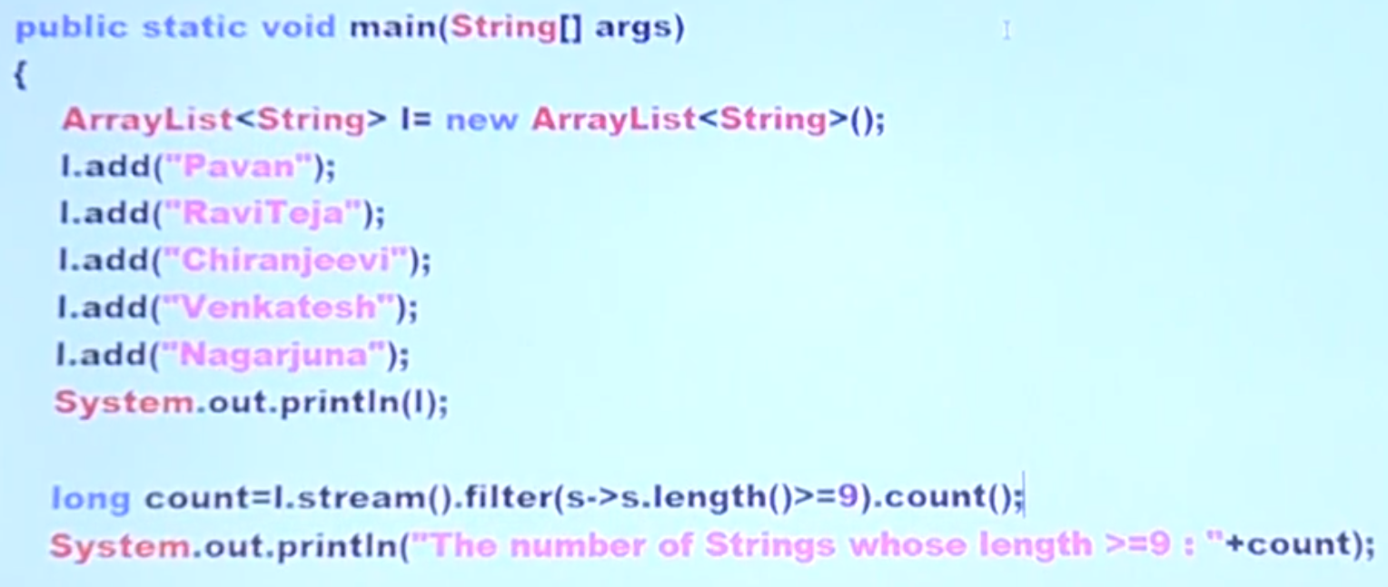

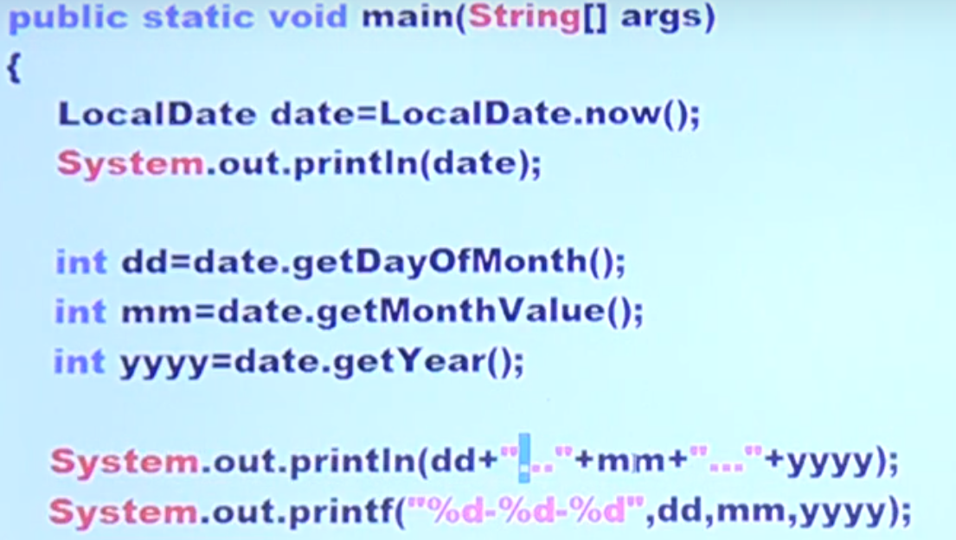

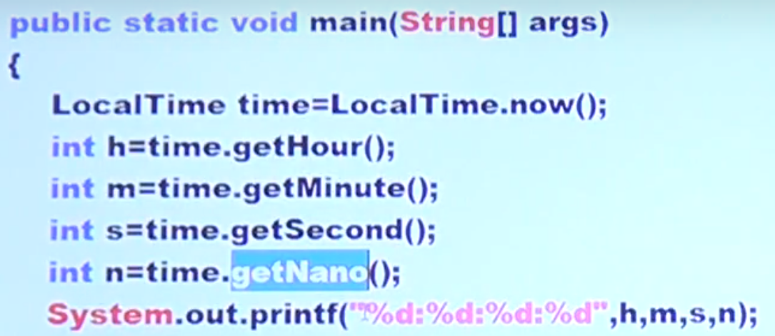

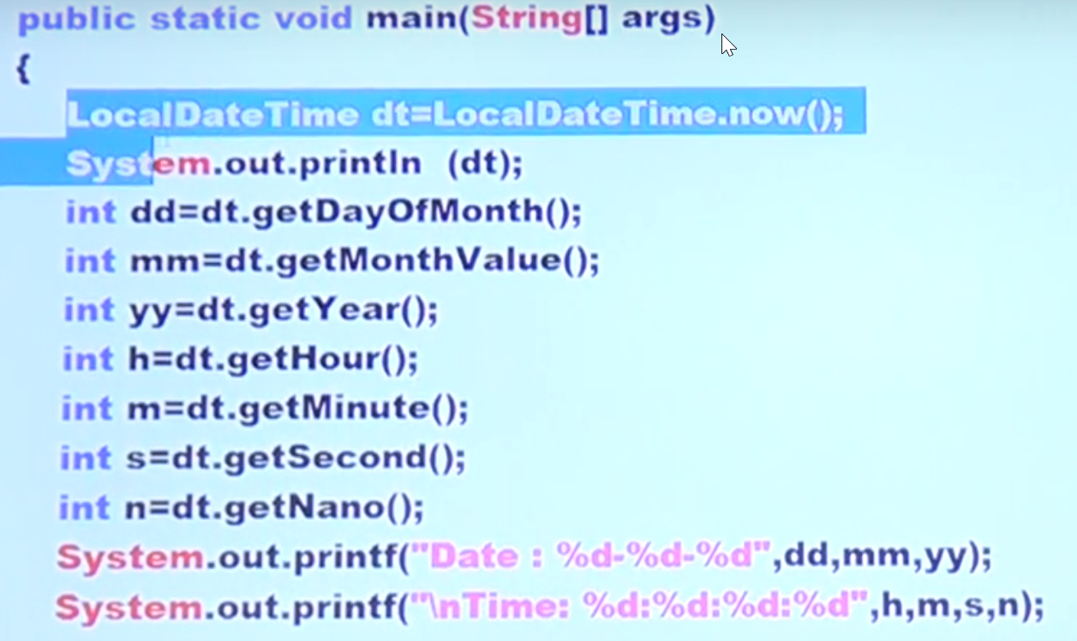



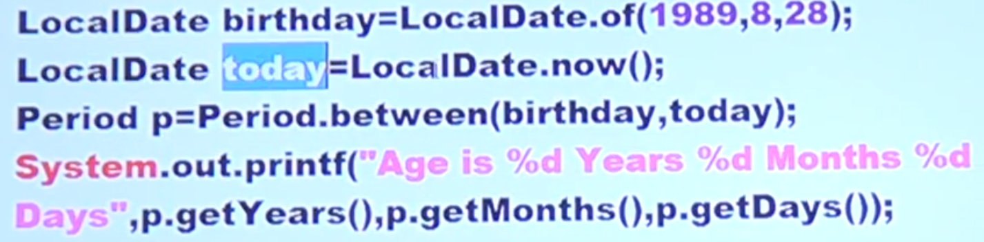

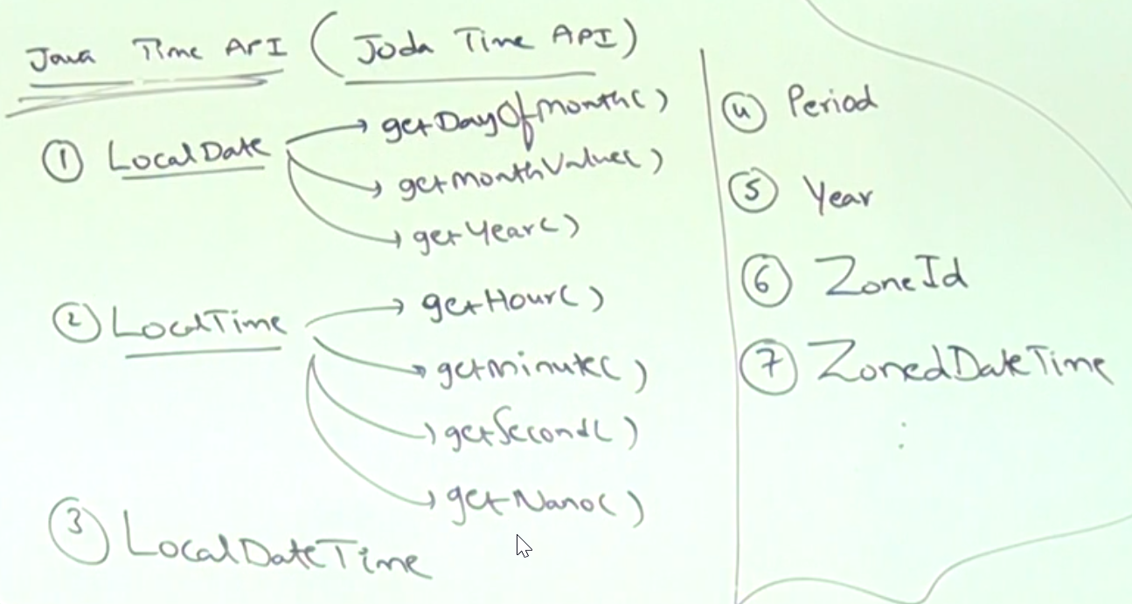

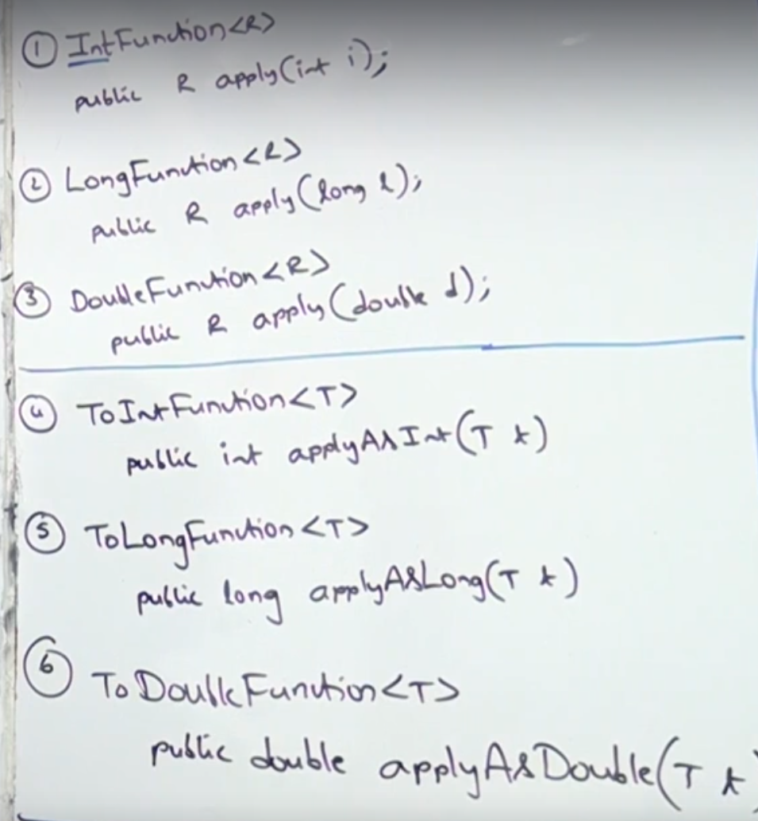

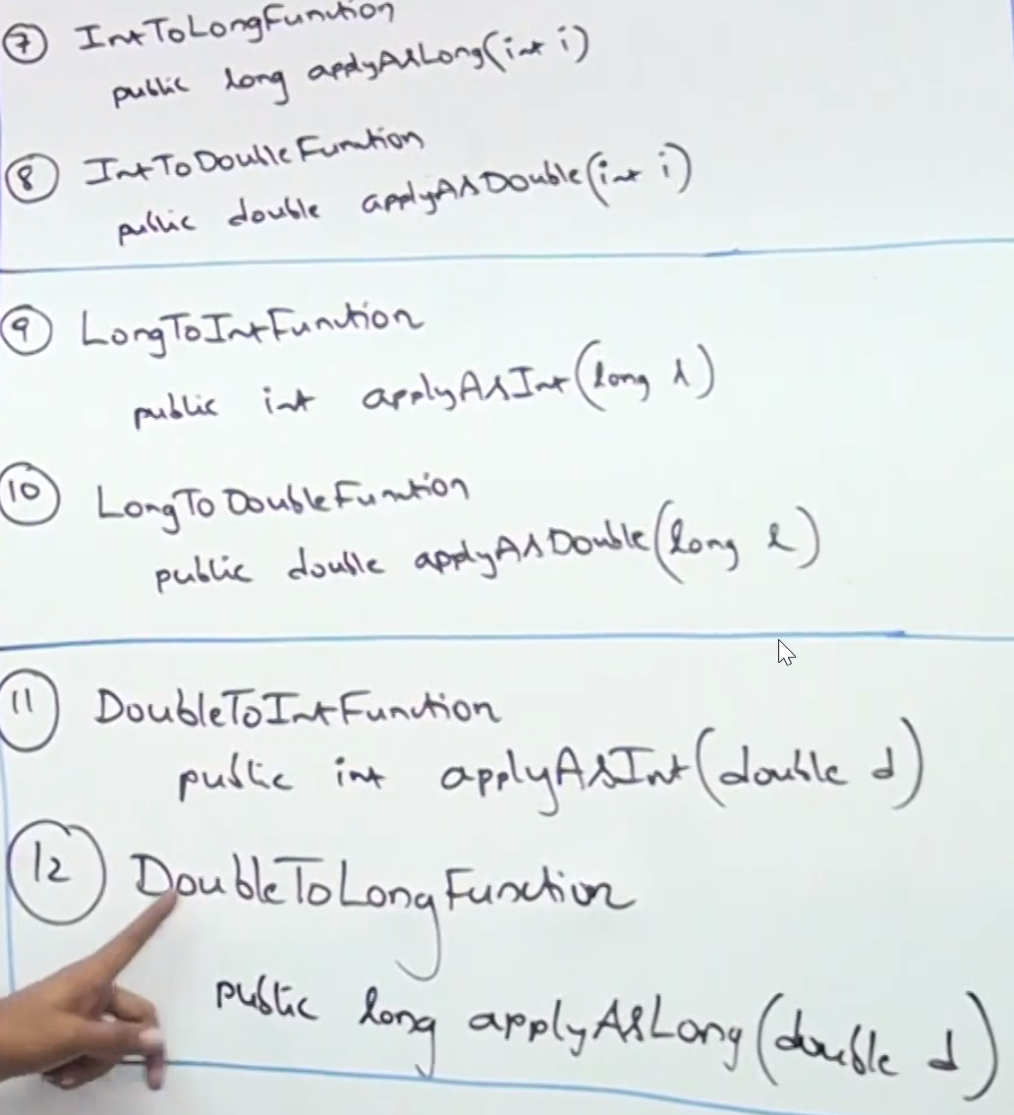

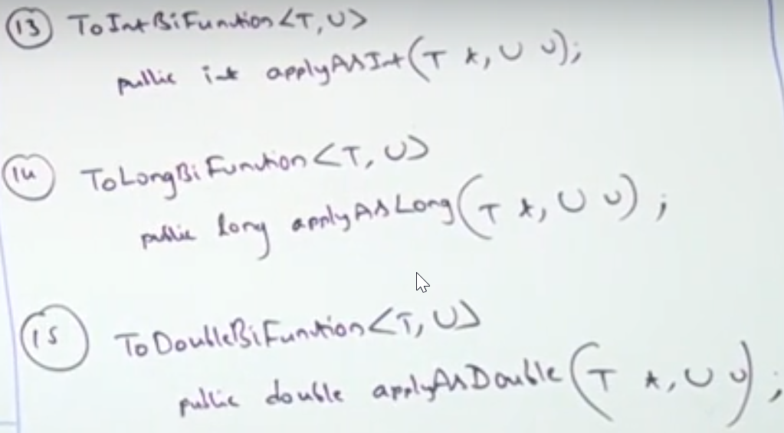

* Primitive Consumers
  + IntConsumer, LongConsumer, DoubleConsumer
  + ObjIntConsumer, ObjLongConsumer, ObjLongConsumer
* Primitive Suppliers
  + IntSupplier – public int getAsInt()

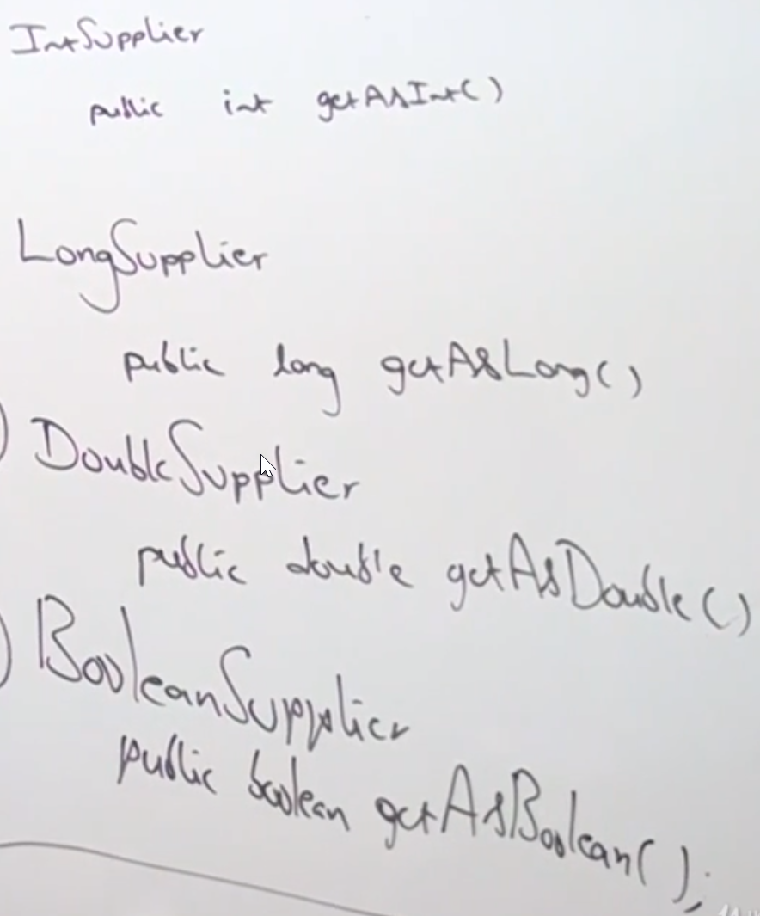

**Input type & Output type both are same then use below instead of Function interface.**

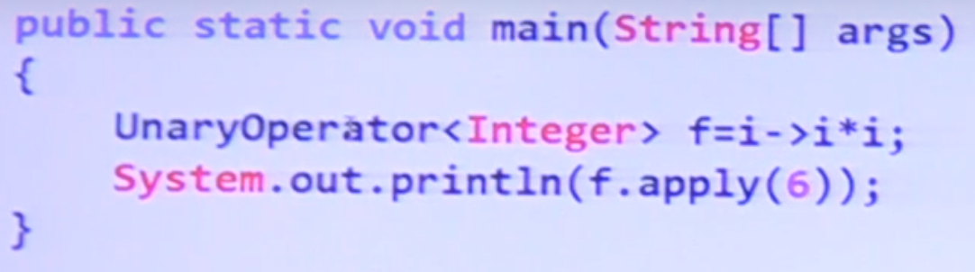

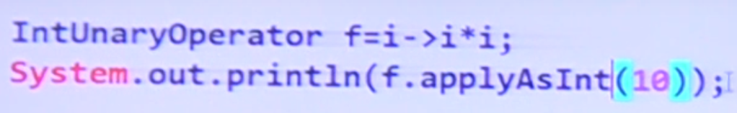

**Same way LongUnaryOperator, DoubleUnaryOperator**

BiFunction( T, T, T ) 🡪 BinaryOperator() ( 2 input and return all 3 are same then go for BinaryFunction )

Function( T, T ) 🡪 UnaryOperator() input and output both are same type then go for UnaryOperator

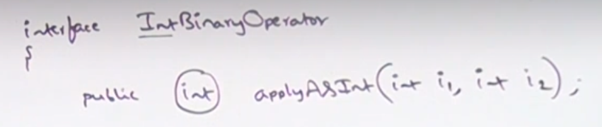

**LongBinaryOperator**

**DoubleBinaryOperator**

* Stream
  + A stream is a sequence of elements from a source that supports data processing operations.
  + Streams make use of internal iteration: the iteration is abstracted away through operations such asfilter, map, and sorted.
  + There are two types of stream operations: intermediate and terminal operations.
  + Intermediate operations such as filter and map return a stream and can be chained together. They’re used to set up a pipeline of operations but don’t produce any result.
  + Terminal operations such as forEach and count return a nonstream value and process a stream pipeline to return a result. •
  + The elements of a stream are computed on demand.
* Collectors

|  |
| --- |
|  |
|  |
|  |
|  |
|  |
|  |
|  |
|  |

* Collect --VS-- Reduce
  + Collect is immutable while Reduce is mutable so not a good candidate in parallel processing.
* sfsf